GIMP
Working with Channels and the Alpha Channel.
The Alpha channel adds a transparent background layer to an image.
This image does not have an Alha channel. The file name is in bold.
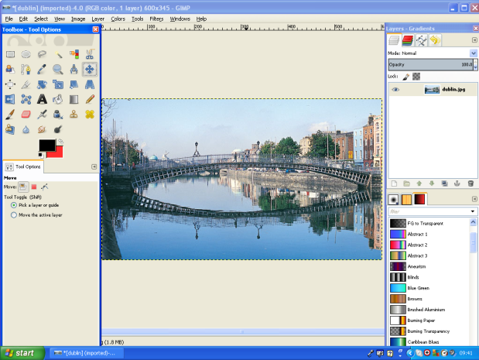

Clicking on the Channels tab shows there are 3 Channels: Red, Green, Blue.

Note that the background colour selected in the Toolbox is Red.
Selecting an area and pressing the delete key shows the Red background underneath.

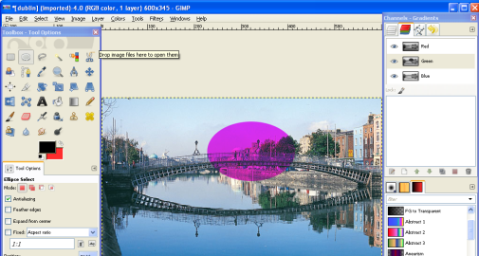
By selecting a channel and pressing the delete key that channel can also be removed from a selected area.

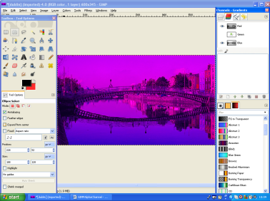
Without an area selected a channel can be switched off by clicking on the eye in the channel menu.

Adding an Alpha Channel:
Right click on the eye and select Add Alpha Channel.
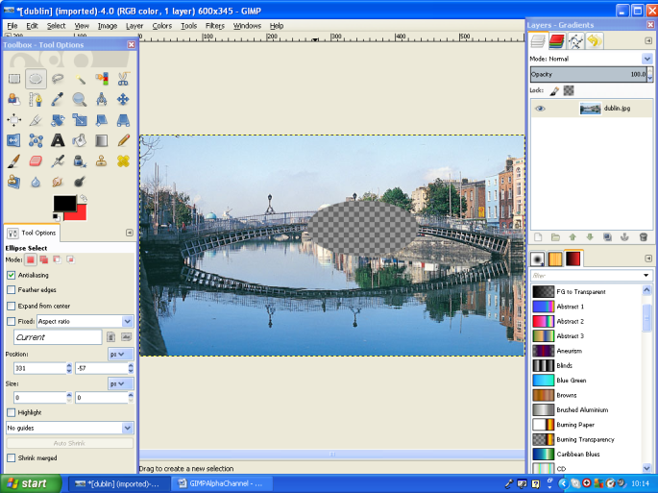
The file name is no longer in bold – this indicates that there is an alpha channel.
Clicking on the channels menu shows an Alpha Channel has been added. If an area of the image is now selected and deleted a chequered area is shown – this indicates a transparency.
With 2 image files opened as layers – the top file has an Alpha channel and an area can be selected and deleted to reveal the layer below. Note the second layer does not have an Alpha file.
