GIMP – Graphics Image Manipulation programme.
Photo manipulation task:
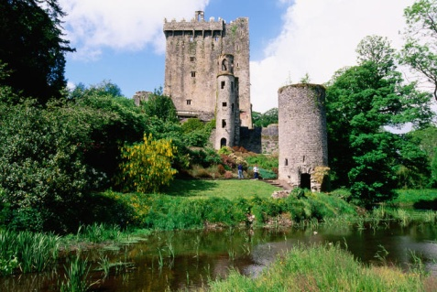
Starting with a colour photograph change it into a grainy and tinted photo
- Original image.

- Open image in GIMP. Adjust contrast (Tools – Colours – Brightness –Contrast)
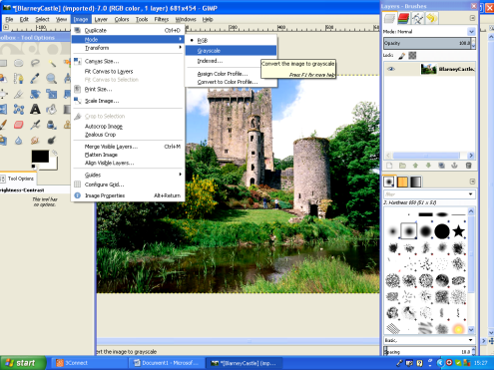
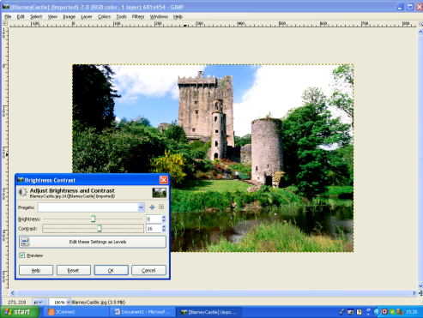
Convert to a black and white photograph (Image – mode – Greyscale)
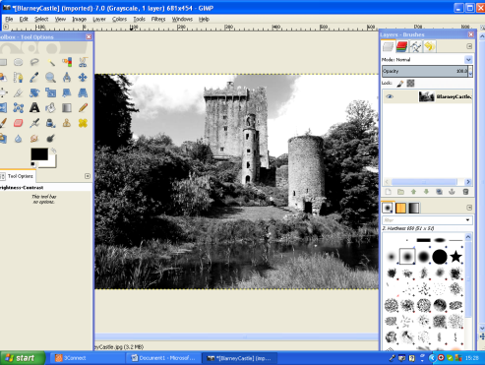
- Add a new layer. (New layer will need to be changed from greyscale to RGB). With the new layer selected Bucket Fill (Toolbox Tool Options menu) with a light orange colour. Ensure Opacity is set to about 30 and Fill Whole Selection is chosen.
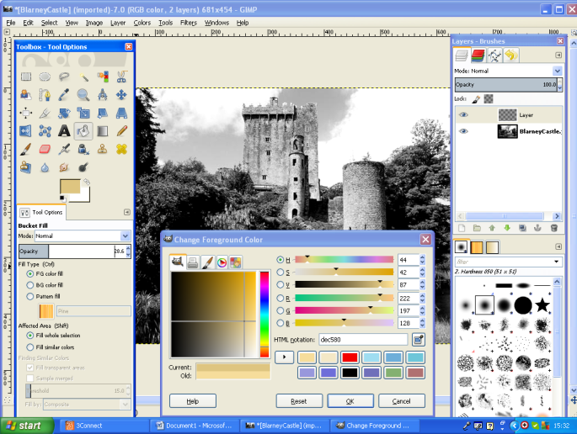
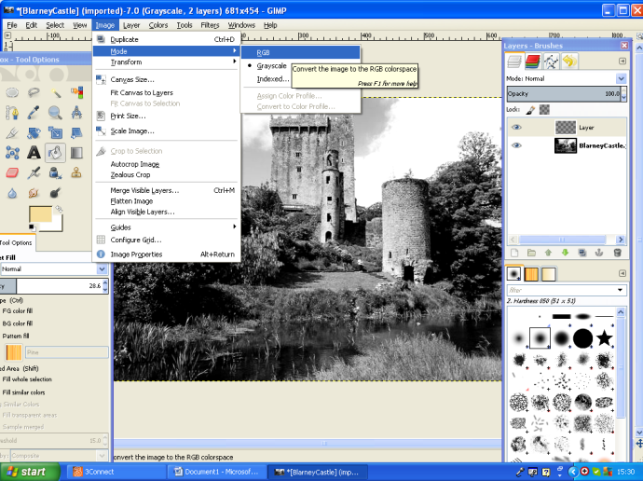

- To add the grainy effect: Filters- Noise – HSV Noise. (increase Value)

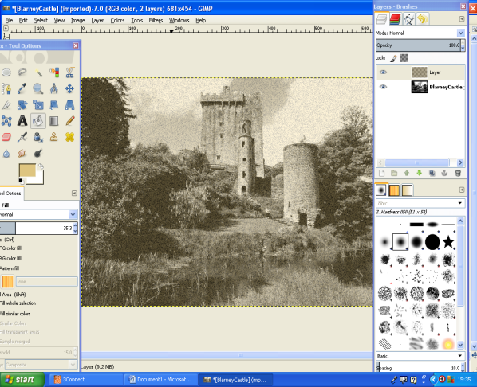
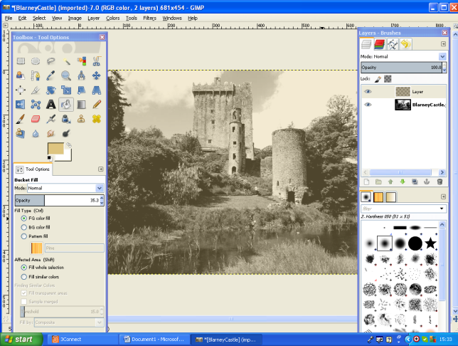

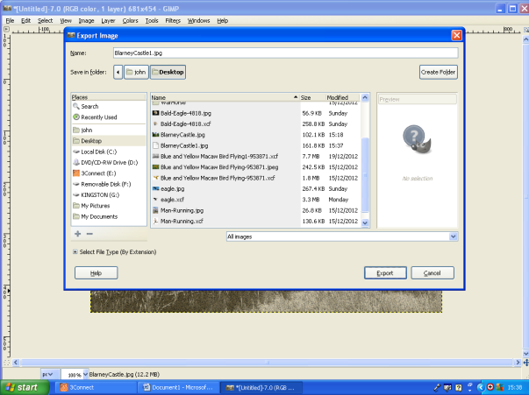
- Export as a .jpg file

