GIMP – Using a Layer Mask and Overlay to Colourize an image
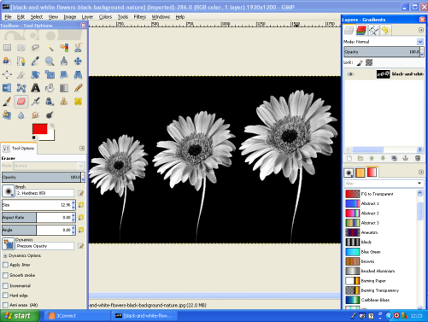
Open an image file of a Black and White Photo. Ensure Image –Mode – RGB

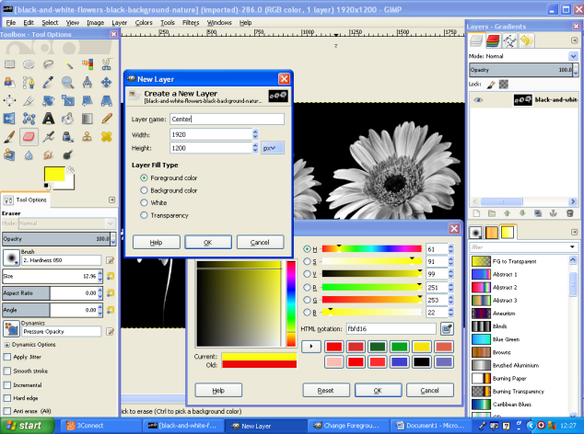
Create a New Layer- Set to Foreground – Set Foreground colour and Name Layer.
Right click on the Layer you have just created and select Add Layer Mask (Black(Full Transparency)).

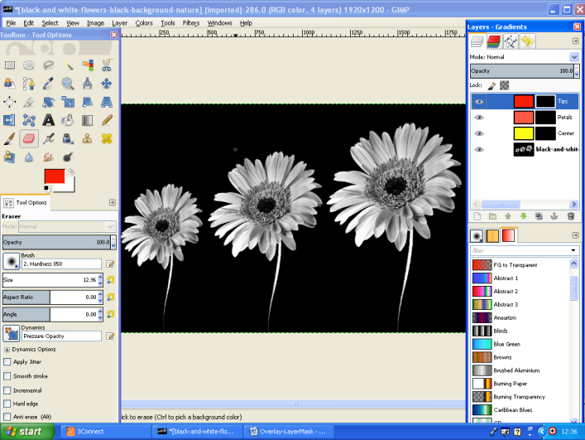
Repeat the process of creating New Layers and Layer Masks for all the areas you wish to Colourize.

Select Mode -Overlay
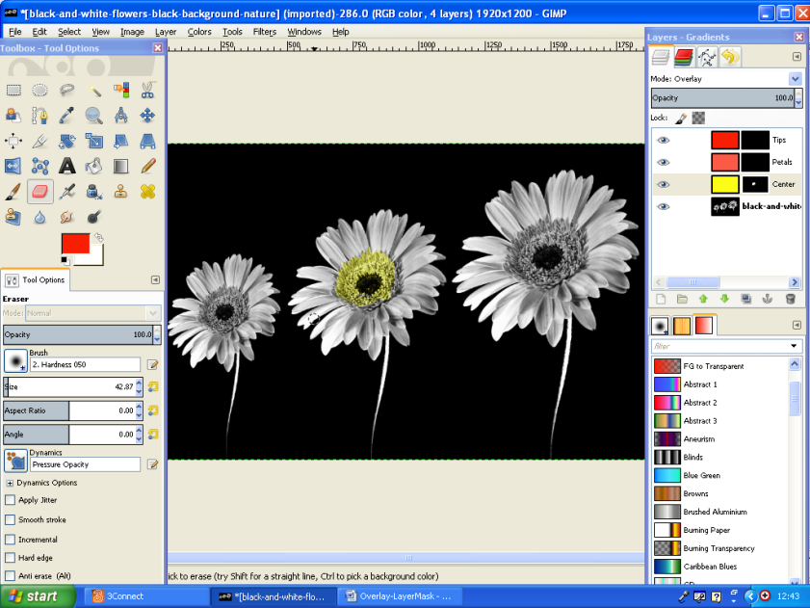
With a Layer selected use the eraser tool to remove part of the Mask.

Start repeating the process for other areas of the image. Make sure Overlay is selected each time.
